41004 – Group 43A
Kim Thai Huynh (Jacy) – 14344358
Ryan Nguyen – 14516355
Affan Abdul Wadood – 25209204
Darrel Phung – 25119241
Muhammad Arrazy – 24682559
Thuy Truc Nguyen (Mina) - 25026814


Watch4U
Context-Aware AI Fall Detection with
Multilingual Staged Escalation for CALD Seniors

Mid-Project Update

Table of Contents
1. Business Problem 2
2. Data Exploration 3
2.1. Computer Vision Dataset: FallVision 3
2.2. Patients’ Medical Profiles 6
2.3. Vietnamese Medical Datasets 8
3. Equipment 10
4. Initial Findings 10
5. Difficulties, risks identified and strategies 12
5.1. Difficulties Encountered 12
5.2. Potential Risks & Strategies 13
6. Updated Project Plan 14
6.1. Refinements Compared to Proposal 15
6.2. Revised Task Breakdown 16
6.3. Updated Gantt Chart 17
7. References 18

Business Problem
Falls among seniors, particularly those from Culturally and Linguistically Diverse (CALD) backgrounds, present a complex, layered challenge that extends beyond simple incident detection. To address this challenge, our company, Watch4U, is developing an AI emergency response system that uses vision-based fall detection alongside context-aware communication and decision-making mechanisms. Our system design is informed by the following issues.
The first critical issue is the detection barrier. When individuals experience a fall and cannot trigger emergency devices or communicate, they may remain on the ground for an extended “long lie” period, which is associated with severe clinical complications such as dehydration, pressure injuries, and delayed treatment. While vision-based fall detection provides a non-intrusive alternative to wearable devices, it introduces important technical limitations in real-world situations. In particular, privacy constraints create critical gaps in detection coverage. Cameras cannot be deployed in areas such as bathrooms, despite these being high-risk locations where falls frequently occur. Furthermore, camera-based approaches are sensitive to occlusion, lighting conditions, and environmental layout, which can further impact detection accuracy.
The second issue is the linguistic and communication barrier. Non-English-speaking seniors often face delays or inability to communicate with emergency responders, particularly in high-stress situations where panic reduces their ability to communicate. This challenge is compounded when individuals are physically unable to speak due to stroke, injury, or shock. Importantly, stakeholder insights reveal that communication breakdown occurs because of language differences and inability to recognize the severity of their condition and how to describe it. As a result, delays can occur at every stage of the emergency response process, whether it is before, during, or after seeking help.
The third issue is the adoption barrier. Even if detection and multilingual communication are technically achieved, Watch4U’s system may fail in real-world scenarios if users do not trust or understand the system. Seniors may feel uncomfortable with in-home monitoring technologies and data collection by institutions. Moreover, AI systems can sometimes miss cultural nuances in how care is expressed, especially when seniors prefer human voices and cultural phrasing.
We also identified a less explicit but equally critical challenge, which is the behavioral barrier. In emergency situations, individuals often experience panic, confusion, or fear, which severely impacts their ability to follow instructions or make rational decisions. Cultural factors can also influence behavior, such as reluctance to call emergency services owing to perceived costs or fear of burdening family members. These insights highlight that our emergency response must be designed to real human behavior under stress, rather than idealized user interaction.
Therefore, the business problem is to improve fall detection accuracy, as well as to design a private-aware, context-aware, and culturally appropriate emergency response system that can operate reliably across real-world constraints. Watch4U aims to address this by combining technical innovation in detection and communication with system-level design that accounts for environmental limitations and human behavior.

Data Exploration
Our data exploration combines both technical datasets and qualitative stakeholder-informed evidence. The technical datasets support the fall detection, communication, and triage components of the prototype, while stakeholder interviews help us understand the patient journey, communication barriers, privacy expectations, and escalation preferences in real emergency situations.

Computer Vision Dataset: FallVision
    - Data Source
FallVision’s link: https://dataverse.harvard.edu/dataset.xhtml?persistentId=doi:10.7910/DVN/75QPKK
FallVision is a public computer vision dataset developed by a group of researchers from University of Asia Pacific, Bangladesh to support research in vision-based fall detection systems. It is designed for machine learning algorithms to distinguish between fall events and normal daily activities using video data. The dataset was collected using commercial recording devices, such as smartphones and cameras, capturing both fall and non-fall scenarios in controlled environments. Its primary objective is to provide a benchmark dataset for evaluating computer vision and deep learning approaches in healthcare monitoring, particularly for detecting potentially dangerous fall incidents in real-world settings (Rahman et al. 2024).
Another well-known public computer vision dataset is OmniFall. The FallVision Dataset was chosen over the OmniFall Dataset due to the better suitability for this project. FallVision provides pre-annotated pose estimation data, allowing direct use without additional processing, whereas OmniFall lacks such annotations and would require extra steps to generate them. Additionally, FallVision has a simpler dataset structure, making it easier to integrate into the modelling pipeline, while OmniFall’s multimodal design introduces unnecessary complexity. Finally, FallVision focuses on indoor environments, which closely match the application setting, whereas OmniFall includes more diverse scenarios that are less relevant. Therefore, FallVision enables more efficient development and is better suited for rapid prototyping.
    - Data Audit
The dataset consists of 11732 videos of both fall events (6002 videos) and non-fall activities (5730 videos) with half of them landmarked, with fall cases categorized into three main types:
- Fall from beds (1974 videos) vs no fall (1792 videos)
- Fall from chairs (1986 videos) vs no fall (1918 videos)
- Fall from standing positions (2042 videos) vs no fall (2020 videos)
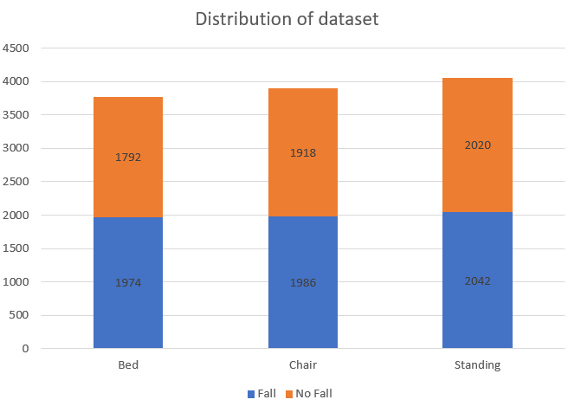
Figure 1. FallVision dataset distribution
FallVision contains thousands of samples, with approximately balanced distributions between fall and non-fall classes. The dataset is organized into hierarchical directories separating fall types, non-fall classes and annotations. Detailed structure of the dataset is shown below:
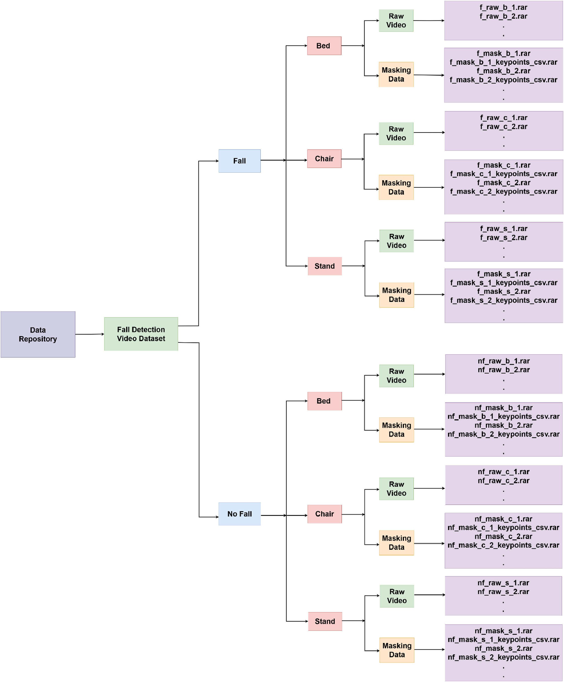
Figure 2:Structure of the FallVision Dataset showing fall and non-fall categories, sub-activities (bed, chair, standing), and data types including raw videos and pose-based masking data (Rahman et al. 2024)
    - Data Preparation and Preprocessing
To prepare for model training, several preprocessing steps are required. Since this is primarily video based, we need to convert videos into image frames. This is necessary when using image-based architecture such as ResNet18 or YOLO, which only allows training with image frames rather than video format.
Additional preprocessing steps include:
- Frame extraction and resizing to ensure consistent input dimensions
- Normalization of pixel values for stable training
- Removal of corrupted or duplicated samples
- Standardizing frame rates across videos
- Label verification and consistency check
    - Data Discovery
Some key characteristics of the dataset have been pointed out in the core paper. First, the dataset is relatively balanced between fall and non-fall classes. However, only 6-7% of the videos involve female participants. Though the gender distribution is not balanced, it does not impact the performance of the model on detecting fall events (Rahman et al. 2024).
Furthermore, this dataset provides a multimodal approach, with the combination of pose estimation data. These can help reduce bias caused by irrelevant features such as lightning, clothing, or background. However, solely focusing on pose data may remove contextual information that could be useful for distinguishing different fall scenarios, therefore, combining raw data with pose features may be more appropriate.
These findings suggest that a vision-only approach may detect obvious falls, but slower and more complex falls experienced by frail seniors remain challenging, which directly affects the reliability of the proposed system.
  - Patients’ Medical Profiles
    - Data Source
Due to confidentiality, ethics, and privacy restrictions, access to real patient medical records is not available for this project. To address this limitation, we worked with Prof. Paul Middleton to design synthetic patient profiles specifically for prototyping and system development. These records are intended to resemble plausible clinical cases without exposing any personal or sensitive information. In the Watch4U prototype, this dataset provides simulated patient histories that allow the system to perform context-aware triage and make more informed escalation decisions after a fall event. This approach is consistent with the project’s early design, where synthetic clinical data was proposed as the Electronic Health Record input for the prototype under privacy constraints.
    - Data Audit
The dataset consists of a collection of patient profiles, where each patient has a single structured medical record. Each record captures key attributes relevant to fall risk assessment and triage escalation.
Each patient includes the following attribute:
- Demographics: age, gender
- Medical history: list of chronic conditions (e.g. hyperextension, stroke)
- Medications: List of current medications, with emphasis on high-risk drugs (e.g. anticoagulants, sedatives)
- Functional status: mobility level (independent, assisted, bedridden) and cognitive status (normal, impaired)
- Fall history: number of previous falls
- Emergency contacts: list of patients’ contacts
Each patient is categorized into a risk level (low, moderate, high) based on predefined clinical rules. A simplified rule-based approach is adopted:
- Major risk factors include:
  - Age ≥ 65
  - History of stroke or cardiovascular disease
  - Use of anticoagulant medication
  - Impaired mobility (assisted or bedridden)
  - Cognitive impairment
- Risk classification:
  - High risk: patients have 2 major risk factors
  - Moderate risk: patients have 1 major risk factor
  - Low risk: patients have no major risk factors
This approach allows the system to personalize triage decisions based on the patient’s background.
As the data is synthetically generated, the data is not required to be preprocessed extensively. Therefore, the data only needs to be standardized and validated to ensure compatibility with the AI agent. Key data validation includes:
- Ensuring consistent data formats and validations for numerical fields (e.g. age >= 0).
- Structuring all records into JSON format.
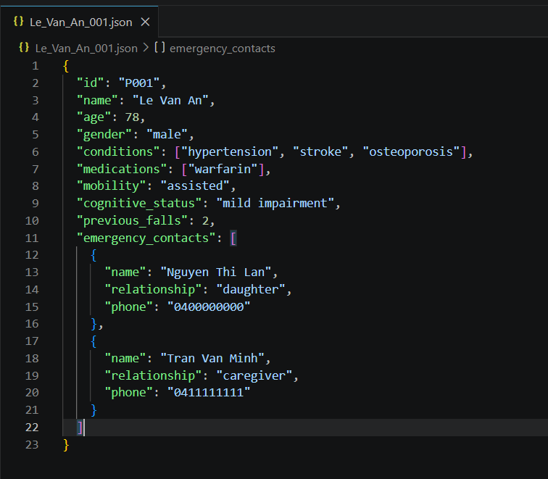
Figure 3: Example of a patient profile JSON file
A key consideration is the trade-off between data realism and data accessibility. Real patient data would provide higher fidelity, but privacy regulations and constraints make it inappropriate for early-stage development. Therefore, synthetic data was used as an alternative to test the prototype and triage without compromising patient confidentiality.
Additionally, the dataset is solely focused on clinical representations, rather than on scale or quantity. The attributes chosen are specifically aligned with known fall-risk factors and triage criteria, ensuring that the system can make meaningful and explainable decisions.
    - Data Discovery
Our exploration suggests that patient context materially changes the meaning and urgency of a fall event. A fall involving a low-risk patient is not equivalent to a fall involving an older patient with impaired mobility, anticoagulant use, or stroke history. This confirms that fall detection alone is insufficient for the business problem; the system must also incorporate health context when determining whether to notify family, continue monitoring, or escalate to emergency services. However, this dataset also reveals its own limitation: while synthetic patient profiles are useful for prototyping rule-based triage logic, they do not capture the lived experience of CALD seniors and carers. For this reason, escalation preferences and communication requirements are informed by stakeholder interviews rather than synthetic records alone. For example, Ms. Jaithoon emphasized the importance of reliability, privacy, and being contacted first so she could judge the seriousness of her mother’s condition, while Ms. Van Trinh highlighted that panic, symptom misunderstanding, and stroke-like cases may require faster emergency-first escalation. These findings show that synthetic clinical data is appropriate for modelling health risk, but community-informed qualitative data is essential for designing the real-world response workflow.

Vietnamese Medical Datasets
    - Data Source
Dataset | Type | What it contributes | Limitation | Link
ViMQ | Medical questions with intent + entity annotation | Helps model patient-style medical phrasing and symptom-focused questions | Not a triage or escalation dataset | https://arxiv.org/pdf/2304.14405
VietMed-NER | Spoken medical NER dataset | Useful for extracting symptoms and medical entities from speech | Focus on language understanding, not decision logic | https://arxiv.org/pdf/2406.13337
ViMedical Disease | Disease/symptom text resource | Broadens Vietnamese health vocabulary | Limited value for emergency escalation without additional logic | https://www.kaggle.com/datasets/pb30025030/vimedical-disease
Table 1: Overview of the Vietnamese medical datasets
To support the multilingual communication layer, we explored three Vietnamese medical-language resources from academic and open-source sources. The first is ViMQ, a Vietnamese medical question dataset created for healthcare dialogue development. According to the paper, ViMQ contains 9,000 Vietnamese medical questions collected from the online consultation section between patients and doctors on the Vinmec hospital website, and each question is annotated for both intent classification and named entity recognition. We also examined VietMed-NER, which is described as the first publicly available spoken medical named entity recognition dataset, built from real-world Vietnamese medical speech and designed for extracting clinically relevant entities from spoken interactions. In addition, we reviewed open-source Vietnamese disease and symptom resources such as the ViMedical Disease dataset to expand the range of patient-facing health vocabulary available to the communication component.
    - Data Audit
Our audit showed that these Vietnamese medical resources are mainly text-based or speech-transcript-based rather than structured triage records. ViMQ is especially useful because it contains both intent labels and medical entity annotations, which makes it relevant for understanding the kinds of questions users ask in healthcare contexts.
The paper identifies four intent categories in ViMQ:
- Diagnosis
- Severity
- Treatment
- Cause
Three main entity types:
- SYMPTOM&DISEASE
- MEDICAL PROCEDURE
- MEDICINE
This is valuable for our project because it helps the system recognize symptom-focused Vietnamese phrasing and distinguish between different communicative purposes.
VietMed-NER is useful for a different reason: it focuses on spoken medical language and includes 18 entity types, making it more relevant to a speech-based emergency interaction pipeline. However, our audit also showed that these datasets do not provide escalation labels, fall severity labels, or emergency decision categories. Therefore, they are appropriate for improving communication quality, but not for determining triage outcomes on their own.
    - Data Preparation and Preprocessing
Because these resources come from multiple heterogeneous sources, preprocessing is required before they can be used consistently in the prototype. Our preparation process includes removing duplicate entries, filtering out content that is too broad or overly technical for emergency use, standardizing text encoding, and cleaning formatting inconsistencies. Longer passages are segmented into shorter chunks so that symptom-related content can be retrieved more efficiently. We also prioritize patient-facing language such as symptom descriptions and short health questions over encyclopaedical medical explanations, because the Watch4U system requires concise, low-stress emergency prompts rather than open-ended medical conversation. In the proposed communication architecture, the cleaned Vietnamese corpus may support a retrieval-based multilingual layer to improve the contextual appropriateness of prompts and responses, while the decision layer remains rule-based.
    - Data Discovery
Our exploration suggests that general-purpose translation alone is insufficient for this project. A Vietnamese sentence can be grammatically correct but still sound clinically unnatural, ambiguous, or too formal in an emergency interaction. By contrast, datasets such as ViMQ and VietMed-NER provide domain-specific symptom wording and medically grounded phrasing that are more suitable for short emergency prompts. This leads to an important business insight: the communication challenge in Watch4U is not simply a translation problem, but a usability problem under stress. The role of the Vietnamese dataset is therefore to improve how the system phrases and interprets symptom-related language, rather than to replace the triage decision logic itself. This is also consistent with stakeholder interview findings, which showed that communication breakdown for CALD seniors is driven not only by limited English, but also by panic, symptom misunderstanding, and difficulty describing what is happening in real time.

Equipment
Our prototype will use a laptop camera for all testing purposes. This is because it is already connected to a laptop and has built in Wi-Fi capabilities to test. In a complete build, we would have separate cameras and a small controller such as an ESP32 board with Wi-Fi to make the build as small and low cost as possible.

Initial Findings
Based on data exploration and early modelling, several key findings have emerged that deepen the understanding of the business problem and inform the direction of system development.
  - Fall Detection Accuracy
Initial testing using the FallVision dataset with pose estimation techniques (MediaPipe and YOLO) indicates that clear, abrupt falls such as falling from a standing position can be detected with reasonable accuracy. However, slow or gradual falls, such as sliding off a chair or slowly collapsing against a wall, are significantly harder to classify. This is consistent with the dataset's composition, which primarily features healthy actors performing simulated, dramatic falls rather than the slower, frailer movements typical of elderly individuals. These findings suggest that additional techniques such as temporal scaling or time-on-floor tracking will be necessary to reduce false negatives in real-world deployment.
  - Privacy and Coverage Gaps
A critical finding from both the data exploration and stakeholder interviews is that camera-based detection alone cannot provide full coverage. High-risk areas such as bathrooms and bedrooms, where falls frequently occur, are unsuitable for camera placement due to privacy concerns. Stakeholder feedback from Ms. Jaithoon reinforced that seniors may actively reject optical cameras in these spaces. As a result, Wi-Fi-based fall detection using Channel State Information (CSI) has been identified as a complementary, privacy-preserving alternative. Relevant datasets (FallDeFi, ToiFall, FallDeWideo) have been sourced, though analysis has not yet commenced due to hardware constraints around ESP32 microcontrollers.
  - Linguistic and Communication Barriers
Early exploration of multilingual support reveals that standard translation tools can produce Vietnamese emergency prompts, but medical terminology is often inaccurate or unnatural. This confirms that a simple translation approach is insufficient for reliable communication with CALD seniors. A pipeline using PhoBERT embeddings with a RAG architecture, supported by Vietnamese medical datasets, is being developed to improve contextual accuracy.
  - Non-Verbal Communication
It was identified that some users may be physically unable to speak during an emergency due to stroke, injury, or panic. Early prototyping of a hand-raise gesture detection module using MediaPipe pose landmarks shows that this approach can reliably detect a raised hand under well-lit conditions, offering a viable non-verbal distress signal. However, performance is dependent on lighting and camera angle, which will require further testing.
  - Behavioral and Adoption Barriers
Stakeholder interviews revealed additional challenges not initially anticipated. Ms. Van highlighted that some seniors hesitate to call emergency services due to perceived costs, even when medical attention is urgently needed. This behavioral tendency introduces risk of delayed response that the system must account for through automated escalation rather than relying on the user to initiate contact. Furthermore, feedback indicated that a generic or robotic AI voice could increase panic rather than provide reassurance, reinforcing the need for a calm, culturally appropriate voice persona in the interaction layer.
  - Long Lie Detection
A key insight is that fall detection alone is not sufficient. The system must also determine whether a person remains on the ground for an extended period, as prolonged immobility significantly increases the risk of complications. This has informed the development of time-on-floor tracking logic, where the system monitors posture over a predefined duration before escalating alerts, rather than triggering immediately upon detecting a fall event.
  - Exact time Threshold for Escalation
The exact time threshold for escalation has not yet been finalized and will need to be determined during the modelling phase. However, based on the staged alert logic and CDSS risk classification described in this report, a risk-adjusted threshold approach is proposed. After a fall is detected, the system will first attempt to assess the user's condition through voice prompts and gesture detection. If no response is received within a short confirmation window, the system will notify the designated carer, consistent with Ms. Jaithoon's preference to be contacted first so she can judge the seriousness of the situation. If the user remains immobile beyond a longer threshold, the system will escalate directly to emergency services. For high-risk patients, such as those with stroke history, anticoagulant use, or impaired mobility, this threshold should be shorter to reflect the increased clinical urgency, as supported by Ms. Van Trinh's observation that stroke-like cases may require faster emergency-first escalation. The specific durations for each risk level will be refined during development and validated with Prof. Paul Middleton to ensure they align with clinical triage protocols.
  - Clinical Triage with Synthetic Data
Due to privacy regulations, real patient data for CALD seniors is inaccessible. Synthetic patient profiles have been generated to prototype the Clinical Decision Support System (CDSS). While these profiles enable early development and testing of rule-based triage logic, there is a recognized risk that they may not accurately reflect the complex, compounding comorbidities seen in real patients. Ongoing validation with Prof. Paul Middleton is planned to ensure clinical robustness.
Overall, the findings confirm that the business problem extends beyond fall detection. The system must address privacy constraints, communication barriers (both linguistic and physical), behavioral tendencies under stress, and the limitations of synthetic clinical data to deliver a reliable and trustworthy emergency response for CALD seniors.

Difficulties, risks identified and strategies

Difficulties Encountered
    - The Privacy Dilemma
Difficulty: Camera’s record everything that happens in their field of vision. This, by the nature of it, is intrusive to the privacy of someone’s home. Stakeholder feedback from our interview with Ms. Jaithoon highlighted a severe privacy barrier that seniors may actively reject optical cameras in general but especially in highly vulnerable areas like the bathroom, despite these being high-risk zones for falls. Placing a traditional lens in these spaces potentially violates user dignity and creates a massive barrier to adoption.
Strategy: To address this, we expanded our data exploration beyond optical computer vision and researched wireless sensing modalities. We identified Wi-Fi based fall detection as a highly viable, privacy preserving alternative. Through this alternative method, the system could theoretically track human movement and detect falls through walls without capturing any identifiable visual data, addressing the key privacy issue.
    - Wi-Fi Hardware Constraints
Difficulty: Upon researching Wi-Fi-based detection, we hit a logistical wall. We discovered that extracting the necessary Wi-Fi Channel State Information (CSI) to train our fall detection model specifically requires ESP32 microcontrollers. These specialized IoT modules are essential for capturing the raw radio wave disruptions caused by human movement, but our team does not currently possess the required ESP32 hardware to build the sensing array.
Strategy: We are currently reaching out to various avenues to see if we can source the necessary ESP32 unit.
    - Data Protection
Difficulty: Raw camera feed and health data are very sensitive information and need to be highly protected. During our stakeholder interview, Ms. Jaithoon emphasized that she would only adopt a monitoring system if she had total clarity on its data lifecycle. Specifically, carers are highly anxious about how visual data is captured, where health profiles are hosted, and who ultimately has access to this information. Without total operational transparency, the system faces a critical adoption barrier.
Strategy: To alleviate anxiety about the camera feed, we plan on processing all data locally. The system would instantly extract the required data and immediately overwrite the video cache, ensuring no raw footage is ever uploaded to an external server. For health data, we are planning on a system that in the event of an emergency, health data can be shared with relevant health staff. We plan on structuring our system in such a way that data would be inaccessible by any other person other than health staff during emergencies, and carers.
    - Accessibility
Difficulty: During our stakeholder interview, Ms Jaithoon pointed out that the rapid speed of technological advancement makes it incredibly difficult for seniors and their carers to adapt. Traditional emergency tech requires seniors to actively participate, remembering to wear a pendant, knowing how to charge batteries, or navigating complex interfaces. In a high stress emergency, asking a panicked, potentially injured senior to operate unfamiliar technology is a critical point of failure.
Strategy: Our system requires zero active interaction, there is nothing to wear, nothing to charge, and no buttons to press. The system passively monitors and uses simple voice prompts to check on them, removing any complexity.
    - Tone of Interactions
Difficulties: We discovered that a generic, robotic AI voice could potentially cause seniors to panic, worsening their mental state in emergency scenarios.
Strategies: As per Ms. Van’s advice, we plan to make the AI persona have a calm, middle-aged female voice delivering prompts slowly and clearly to de-escalate panic in emergency scenarios.

Potential Risks & Strategies
    - Synthetic Clinical Data Bias
Risk: As we cannot legally access real Electronic Health Records (EHR) due to privacy laws, we are generating synthetic medical profiles to test our CDSS. There is a high risk that our mock profiles will not accurately reflect the compounding coexisting conditions seen in real CALD seniors, potentially causing our triage logic to misclassify.
Strategy: To ensure our synthetic data remains clinically robust, we will validate our mock patient profiles and triage outputs against the clinical expertise of Prof. Paul Middleton, ensuring our CDSS strictly mirrors actual hospital triage protocols.
    - Data Interception Risks & API Security Vulnerabilities
Risks: Integrating the Context Layer with the Communication Layer potentially introduces cybersecurity vulnerability. As we are planning to make use of pretrained language API streams to handle communication, or if it transmits raw medical data over unsecured channels during an escalation, there is a high risk that sensitive patient health data could be leaked or intercepted by malicious actors.
Strategies: We could make use of encrypted payloads. Any medical metadata that must be transmitted during a Category 1 or 2 escalation to emergency services will utilize End-to-End Encryption. The data payload will be tokenized, ensuring that even if the API stream is intercepted, the patient's identity and medical history remain completely unreadable to unauthorized parties.
    - The Alarm Fatigue
Risks: Ms. Jaithoon stated that while she wants instant notifications, frequent false alarms will ruin her trust. If our model triggers an alert every time her mother sits heavily on the floor, she will experience alarm fatigue and may be unwilling to continue using the system.
Strategies: To address this, we can make our model not trigger an alert based solely on the speed of a downward motion. We could implement State Machine Logic to track Time on Floor where the system would wait a predefined number of seconds to confirm the subject cannot get back up before initiating an alert, significantly reducing false positives.
    - Slow Fall & Environmental Cluster
Risks: The videos in our dataset primarily feature healthy actors performing simulated, dramatic falls. Seniors also experience slow falls, such as slowly sliding down a wall. Our CNN risks becoming biased toward fast motions, causing potential false negatives in deployment.
Strategies: To address this, we could apply temporal scaling which slows down the video data during training to mimic the kinematics of frail seniors experiencing slow falls.

Updated Project Plan
Since the initial plan, our team has completed data exploration and stakeholder interviews, which have provided us valuable insights into the technical and real-world challenges of fall detection and emergency response. These activities have validated the core system analysis proposed in our Plan and Proposal document. As a result, the initial analysis remains valid and has been reinforced by our exploration and findings, as well as stakeholder input. However, our findings also helped us strengthen our understanding of system requirements, especially around deployment constraints, communication under stress, and the practical behavior of users during emergencies.

Refinements Compared to Proposal
Although the core system analysis and design remain unchanged, certain refinements have emerged from the team’s findings to upgrade our system’s effectiveness.
    - Privacy Coverage
Proposal: The initial proposal acknowledged that cameras cannot be used in sensitive areas such as bathrooms, this limitation is now understood as a critical gap in system coverage. As a result, the team recognizes that camera-based detection alone cannot provide a complete solution.
Refinement: Alternative sensing approaches, such as Wi-Fi-based detection, have been identified as potential future extensions to address these blind spots, although they are outside the scope of the current prototype.
    - Explicit Non-Verbal Interaction Support
Proposal: Non-verbal interaction was included conceptually but not clearly defined in terms of implementation.
Refinement: This aspect is now more explicitly developed. The system will incorporate gesture-based responses, such as detecting a hand-raise using MediaPipe, to support users who are conscious but unable to speak during injury or panic.
    - Explicit Emergency Prompt Workflow
Proposal: Simple emergency prompt was mentioned but examples were not given.
Refinement: The team was guided by the stakeholders to adopt a minimal interaction approach, using simple, predefined prompts to assess the user’s condition. These prompts are designed to be clear and actionable in emergency situations, for example: “I have detected a fall, are you okay?” and “Are you able to speak?”, and “If you hear me but cannot speak, please raise your hand.”
    - Enhanced Multilingual Communication Pipeline
Proposal: The system proposed a translation pipeline using ASR and NMT models for multilingual communication.
Refinement: The communication component is refined into an API multilingual pipeline, supported by STT/TTS (Speech-to-Text/Text-to-Speech) services. This is enhanced with RAG over Vietnamese healthcare datasets and PhoBERT embeddings to ensure contextually relevant and culturally appropriate responses.
    - Time-on-Floor Logic
Proposal: Fall detection focused primarily on identifying fall events.
Refinement: The system now incorporates temporal logic to track immobility duration, enabling the detection of prolonged “long lie” situations and supporting more appropriate escalation decisions.
    - Privacy-by-Design
Proposal: Privacy considerations were primarily limited to restricting camera placement in sensitive areas.
Refinement: The system now adopts a privacy-by-design approach, including local processing of visual data and minimization of stored information to reduce risks related to data exposure.
    - System Integration Focus
Proposal: Decision and escalation components were developed in the deployment phase.
Refinement: The project now emphasizes system-level integration, ensuring that detection, interaction, decision-making, and escalation components operate cohesively within a unified workflow. Task planning has been adjusted to support earlier integration, as detailed in the Revised Task Breakdown section.

Revised Task Breakdown
Our project methodology, a hybrid approach combining CRISP-DM (Cross-Industry Standard Process for Data Mining), Agile Scrum, and HCD (Human-Centered Design), remain unchanged. However, as our understanding of the system design has deepened through data exploration and findings, we have revised the task breakdown in the later CRISP-DM phases to reflect a more detailed and realistic picture of what each system component requires. Detailed tasks can be found in the Gantt Chart (Figure 4).
- Detection Component (Task 3.2): The team will implement fall detection using pose-based analysis to identify fall events and monitor user posture, informed by the FallVision dataset. In addition, temporal logic will be incorporated to track user immobility over time, enabling of prolonged “long lie” situations.
- Interaction Component (Tasks 3.3 and 3.4): Multilingual prompts in English and Vietnamese will be implemented to assess user condition, supported by STT/TTS capabilities via pre-trained APIs. This layer will also support non-verbal responses through hand raise detection to accommodate users who are unable to speak.
- Decision Component (Task 3.5): Rather than treating this as a deployment phase’s task, we have moved the development of the Staged Alert Logic Map earlier in the schedule and conducted in the modelling phase. This layer implements a CDSS using rule-based triage logic to determine user responsiveness and guide escalation decisions. This incorporates synthetic medical profiles to enable context-aware triage, allowing higher-risk cases to be prioritized based on individual conditions and contextual factors such as time-on-floor.
- Escalation Component (Task 3.6): Based on the outcomes determined by the decision layer, the system will execute a staged alert mechanism to notify family members or escalating to emergency services depending on the situation. This layer is also moved from the deployment to the modelling phase.
The Modelling and Evaluation phases in the CRISP-DM lifecycle have shifted from a focus on model deployment towards prioritizing interpretable and task-oriented system components.
Additionally, more attention is given to system-level design and integration, particularly in the development of the staged alert logic and multilingual triage workflow. These components ensure that the system can respond appropriately to different user conditions, including cases where users are unable to communicate verbally.
The Agile framework continues to support iterative development and HCD principles remain integral throughout the process to ensure that the system design reflects real user needs, especially in high-stress emergency situations.
Overall, the overarching methodology and plan remain consistent with the initial proposal, with changes concentrated in the granularity of modelling and integration tasks.

Updated Gantt Chart
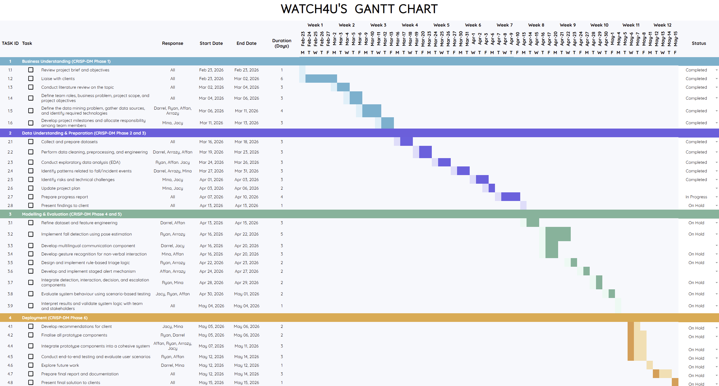
Figure 4: Watch4U’s Gantt chart
Our team has completed the first three phases of the CRISP-DM lifecycle, with the remaining work focusing on Modelling, Evaluation, and Deployment. Although tasks have been rearranged to reflect updated priorities and system refinements, the final delivery timeline remains unchanged.

References
Huy, TD, Tu, NA, Vu, TH, Minh, NP, Phan, N, Bui, TH & Truong, SQH 2023, “VIMQ: A Vietnamese Medical Question Dataset for Healthcare Dialogue System Development,” arXiv (Cornell University), https://doi.org/10.48550/arxiv.2304.14405.
Le-Duc, K, Thulke, D, Tran, H-P, Vo-Dang, L, Nguyen, K-N, Hy, T-S & Schlüter, R 2024, “Medical spoken named entity recognition,” arXiv (Cornell University), http://arxiv.org/abs/2406.13337.
pb30025030 n.d., ViMedical Disease Dataset, Kaggle, viewed 11 April 2026 https://www.kaggle.com/datasets/pb30025030/vimedical-disease.
Rahman, NN, Mahi, ABS, Mistry, D, Masud, SMRA, Saha, AK, Rahman, R & Islam, MdR 2024, Fall Vision: a benchmark video dataset for advancing fall detection technology, Harvard Dataverse, https://doi.org/10.7910/dvn/75qpkk.

